
QUALITY ALERT

Customer: Seaway Date: June 9, 2025
Die: 1778 Colour: Any
Type of Complaint: Seaway REJECTED

Q.A # 25-011 NCR: 124 RMA#: 434

Description: Seaway REJECTED due to internal dimensions exceeding tolerance limits, which prevents the aluminium reinforcement from properly fitting into the cavity. The variation in width and diagonal internal dimensions causes interference and results in assembly failure.
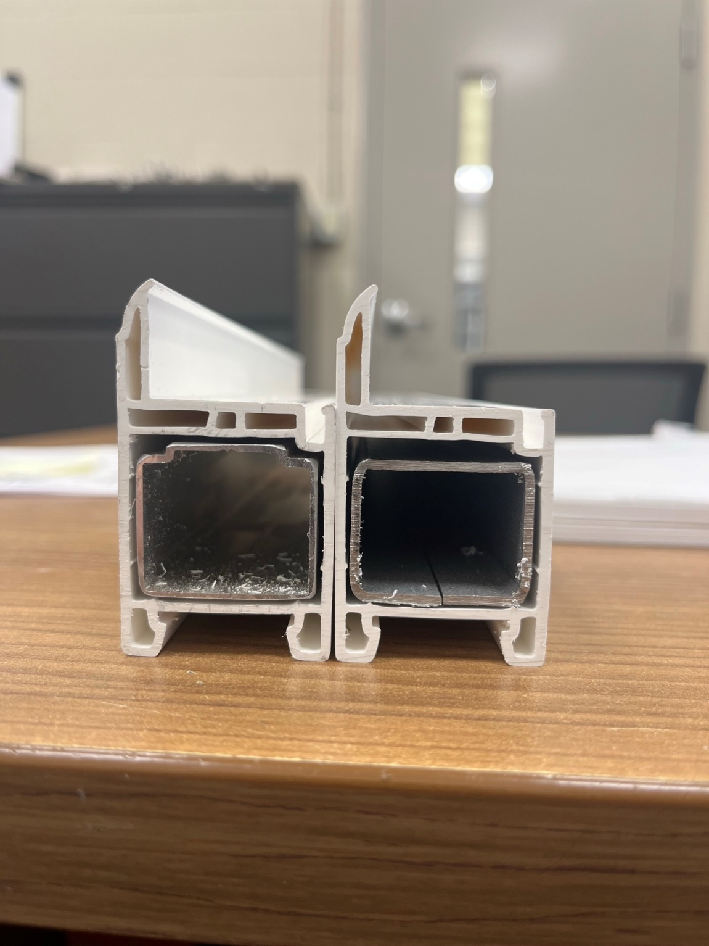
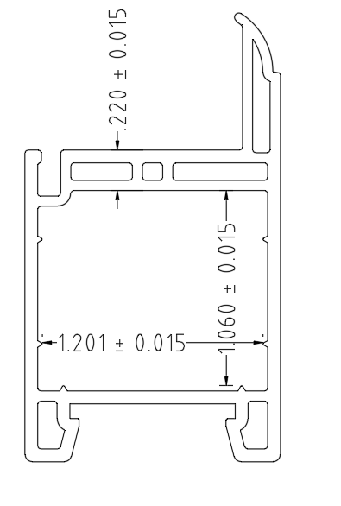
BOTH REINFORCEMENTS MUST FIT LOOSE

ALL INTERNAL DIMENSIONS MUST BE WITHIN SPECIFIED TOLERANCES TO ENSURE PROPER REINFORCEMENT FIT. MUST ENSURE ALUMINIUMS (FROM QC) FIT LOOSE BEFORE PACKING.

BY SIGNING BELOW, YOU ACKNOWLEDGE THE PROBLEM ABOVE AND AGREE TO MONITOR THIS ISSUE IN FUTURE PRODUCTION RUNS.
DAY SHIFT |  | AFTERNOON SHIFT |  | NIGHT SHIFT
NAME | SIGNATURE | NAME | SIGNATURE | NAME | SIGNATURE
F-006: Quality Alert | Eff.Date: 05/03/2025 | CC# 25-046 | Rev.0

